Le Linguine

Wentworth Institute of Technology

Databases

COMP2650

Professor Nguyen Thai

January 29th, 2023

Aniket Jaldu

Jovaughn Olivier

Timmy Tran

Each restaurant location of Le Linguine will be serving our specially selected menu of traditional Italian dishes that include, but are not limited to, pasta, ravioli, lasagna, and linguine. Each main dish also has the option of having cheese and the type is chosen by the customer. There will also be side dishes like pasta salad and garlic bread. The customers will have the choice of choosing if they want the side dishes with their main dishes. An assortment of appetizers and desserts will also be available. In order to ensure satisfaction for our customers, we provide a selection of services provided by our exceptional crew.

Services include luxurious dining areas, facilities for reservations, and waiters that serve your needs. Dining areas consist of an outside seating for the warmer temperatures and our well-crafted couches for those with a craving for indoor dining aesthetics. Reservations can either be made over the phone or on our website, at least 2 hours prior to the actual reservation. In the kitchen, there will be a leading Italian chef who guides and overlooks all the other chefs on how they prepare each meal. Alongside our chefs, we have a well-trained staff that knows how to preserve and store certain food based on their required temperatures. Our waiters are trained to speak to customers courteously and to go out of their way to provide customers with a special service.

Le Linguine is a chain of casual dining restaurants that offers Italian-American cuisine. The restaurant chain is known for its family-friendly atmosphere and affordable prices. Le Linguine offers a variety of dishes, including pasta, soup, salad, breadsticks, and dessert. Some of their most popular dishes include Fettuccine Alfredo, Lasagna Classico, Linguine with Lemon Garlic Sauce, and Spaghetti with Meat Sauce. Cheese is optional with every dish and the type of cheese is chosen by the customer. They also offer gluten-free, vegetarian, and low-fat options to cater to different dietary needs. Further, the restaurant uses a range of kitchen equipment and devices to prepare and serve its food. This includes large commercial ovens, stoves, deep fryers, and refrigerators. They also use various utensils, such as pots, pans, and spatulas, as well as cutting boards and kitchen knives. In addition to this traditional kitchen equipment, Le Linguine also uses modern technology, such as digital ordering systems and point-of-sale terminals, to streamline their operations and enhance the customer experience.

         Le Linguine employs both full-time and part-time employees and said staff is composed of servers, cooks, dishwashers, cleaners, and managers. Salaries come at a moderate level above standard, which means the professions that require higher degrees of experience are paid appropriately in match with their skills. The chain is responsible for managing a range of financial components, including mortgages, electricity bills, and other operational expenses. The company uses a combination of its own revenue and financing from lenders to meet its financial obligations and maintain its operations.

In conclusion, business operations are centered around providing high-quality food, a warm and welcoming atmosphere, and excellent service. By leveraging the right kitchen equipment, managing their employees effectively, and maintaining their financial stability, Le Linguine continues to be a popular choice for dining out. The company's commitment to sustainability and community engagement further sets it apart from its competitors and helps to create a positive image in the minds of its customers.

Regarding ingredient management and business operations, Le Linguine is structurally sound. Le Linguine uses a combination of both made-in-house and purchased ingredients to create its menu offerings. For example, the company makes its own sauces and dressings in-house, while it sources other ingredients, such as vegetables and meats, from external suppliers. Some products, such as soups and sauces, are prepared at a central facility and then distributed to individual restaurants. Other menu items, such as pasta dishes, are prepared fresh in-store. By using a mix of both in-house and purchased ingredients, Le Linguine can efficiently provide quality food and service.

As for its business operations, Le Linguine restaurants provide online and over-the-phone reservations and ordering for take-out as well as catering for dedicated events/occasions. Each restaurant accepts both cash and credit card payments, depending on the customer's preference, and uses secure payment processing systems to protect customer information and prevent fraud. Each table will be equipped with a tablet that allows for easy payment, ordering, and rating of the services.

All in all, Le Linguine’s defined set of business rules helps to ensure consistency, efficiency, and quality across all its locations. From ingredient management to restaurant operations and technology, the company follows a structured approach to managing its business, enabling them to provide a high-quality customer experience.

The hours of operation for each establishment are from 7 in the morning to 10 at night. These times are the operating hours from Monday to Saturday while on Sunday they are 7 AM to 5 PM. There will be multiple shifts covered and split up evenly among the staff of each restaurant. The business is a mix of weekdays and weekends oriented, the busiest days being Tuesdays and Thursdays. Peak hours every day are around dinnertime, 6 PM to 8 PM. The customers can decide whether to dine in or take out during any mealtime. There are also special deals for different mealtimes which allow for both variety and affordability. Special deals include preset combos of a starter, main dish, drinks, and dessert. Additionally, special deals have certain options for the customer to choose from.

Through our online website and advertisements on other sites, digital coupons will be able to be saved and used for both food and reservations. These coupons will not be applicable to the special deals already offered and only one coupon can be used at a time. Coupons can either be scanned using the tablet built into each table or presented in physical form to the servers when customers need to pay.

Restaurant locations vary from place to place, one could be in a mall, and one could be in a restaurant district. These locations can be derived by analysis of demographics to find the prime locations for a casual Italian American restaurant, such as Le Linguine. The restaurant is made to not be seasonal so that exquisite Italian meals can be enjoyed at any time of the year. This helps make the sales during holidays even better since locations are not closed during special days.

Regarding competition, nothing beats the hours of Le Linguine. Most businesses around either operate only on weekdays or have shorter hours of operation. Almost all competitors also aren’t open on holidays. The locations of the restaurants are also located in places where no other Italian restaurants are located within a 5-mile vicinity. Prices are reasonable compared to competitors and location doesn’t affect this too much. A Le Linguine could be located in a fancy restaurant district, but prices would only be slightly more expensive to compensate but would still be affordable to many. Le Linguine looks to bring the atmosphere of Italy to the customers. From lighting to furniture to decorations, a welcoming Italian atmosphere is created within each location. Each restaurant will have different setups for decorations and furniture, but they will still have that Italian atmosphere.

With these ups, there are also its downs. Some disadvantages that Le Linguine has with having a huge chain of restaurants is that the kitchen equipment, maintenance, and operational costs require a big budget. Within each chain of Le Linguine, there can also be problems with staff and the hiring of a huge workforce needed to run the place, which also feeds into that big budget. Alongside economic problems, there are problems when it comes to very highly congested locations, which tend to limit parking for customers and sharing spaces with other restaurants. These areas also cause long wait times and full capacity during busy days. Another disadvantage that comes with location problems is that in some areas the prices that Le Linguine provides may be either cheaper or more expensive compared to their competitors, which can bring less profit. The weather would also be a problem since outside dining would be restricted if there is non-optimal weather. Walk-in dining, not having a reservation and asking for a table, is also not always guaranteed, which could cause customer dissatisfaction.

To enhance Le Linguine's competitiveness in the market, it is crucial to explore various strategies that can improve the business. Expanding the menu is one of the key aspects to consider, but other opportunities include forming strategic partnerships, merging with other restaurants, and acquiring additional spaces. Partnerships with food pantries, for example, will not only enhance Le Linguine's public reputation but also contribute to a noble cause. Merging with other restaurants can bring diversity to the menu and provide customers with a wider range of choices. On the other hand, acquiring other restaurants can address the disadvantages faced by Le Linguine, such as limited parking and space constraints, in highly populated areas. Additionally, introducing seasonal menus and offering special options during holidays can also add to the variety provided by Le Linguine. Another idea is to develop a customer loyalty program through an app, where customers can earn points for ordering food and dining at Le Linguine's locations. These points can then be redeemed for free appetizers or exclusive coupons, which can incentivize repeat visits and address the pricing issues faced by different Le Linguine locations. There can also be the addition of an all-you-can-eat section of the menu where the customers pay a set price so that they can eat as much as they like from a limited menu. The price they pay depends on the time they dine. They will still have access to the entire menu, but it will cost extra. Dinner will be the most expensive time for all-you-can-eat, but it will give customers the largest limited menu to choose from. Implementing a kid’s menu would add more competition since many restaurants have a general menu rather than group targeted menus. This will help emphasize eating as a family which will bring in more people. Kids under a certain age will be able to eat for free if the customers go with the all-you-can-eat option. Furthermore, each restaurant location can have a unique design for its interior or exterior. One location could have large windows that open up to provide a better view and another location could have a glass hangover for the outside seating. These unique features will double as solutions to solve weather-related problems.

**Entities and Attributes**

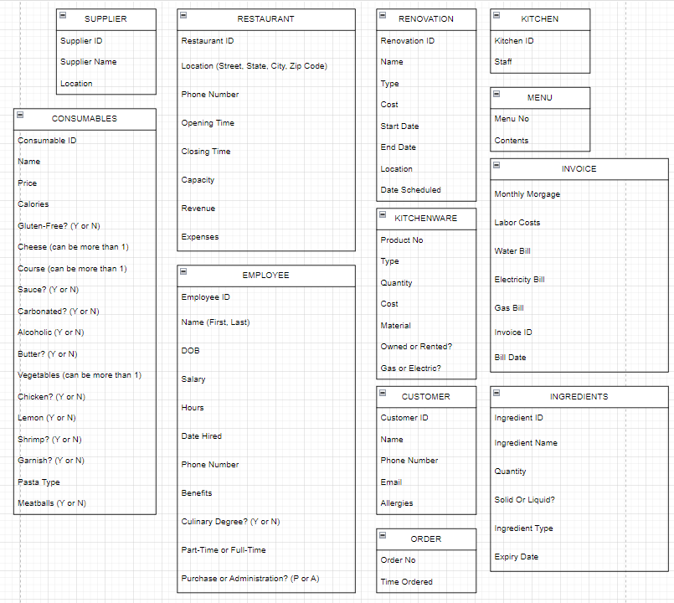

**Entities Relationships**

* A supplier works with one restaurant, but a restaurant must work with one or more suppliers.
* A supplier provides at least one ingredient, and an ingredient must be provided by many suppliers.
* Each supplier sends a shipment of the ingredients it sends.
* Each food item must be made of at least one ingredient, but an ingredient must only be in one food item.
* Each food item uses recipes made up of the ingredients.
* A restaurant has one or more employees, but a single employee can work at only one restaurant.
* A restaurant pays for one invoice, and that invoice is paid by the restaurant.
* A restaurant must house at least one or more kitchens, but the kitchen is housed by only one restaurant.
* A restaurant may fund at least one renovation, but each renovation only affects one restaurant.
* An employee must be either a chef, waiter, or supervisor.
* A supervisor may hire many employees, but an employee must only be hired by a single supervisor.
* A supervisor may also manage an invoice, but an invoice must be managed by one supervisor.
* A supervisor may purchase one or more kitchenware, but kitchenware must be purchased by a single supervisor.
* Kitchenware can either be cookware or equipment, not both.
* Kitchenware must be used be used by a single kitchen, but a kitchen must have at least one kitchenware.
* A chef must create one menu, and that menu is created by one chef. A consumable can be either a food item or beverage, not both.
* A food item must be either Fettuccine Alfredo, Linguine, Lasagna Classico, Italian Pasta, or Spaghetti.
* A consumable must be made by a chef. A chef must make many consumable items.
* A consumable item is served by a waiter. A waiter must serve consumable items.
* A menu must have many consumable items. Consumable items belong to a menu.
* An order item must have at least one consumable. A consumable is an order item.
* An order must have at least one order item. An order item belongs to an order.
* An order must have at least one payment. A payment must have an order.
* A payment must have a customer. A customer must have at least one payment.

**ERD**

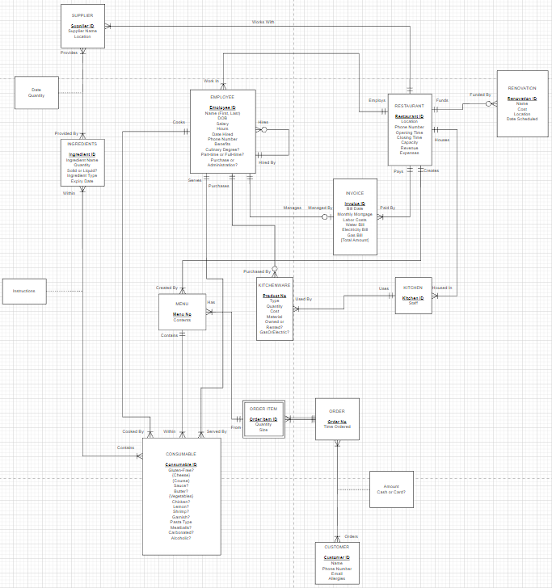

**EERD**

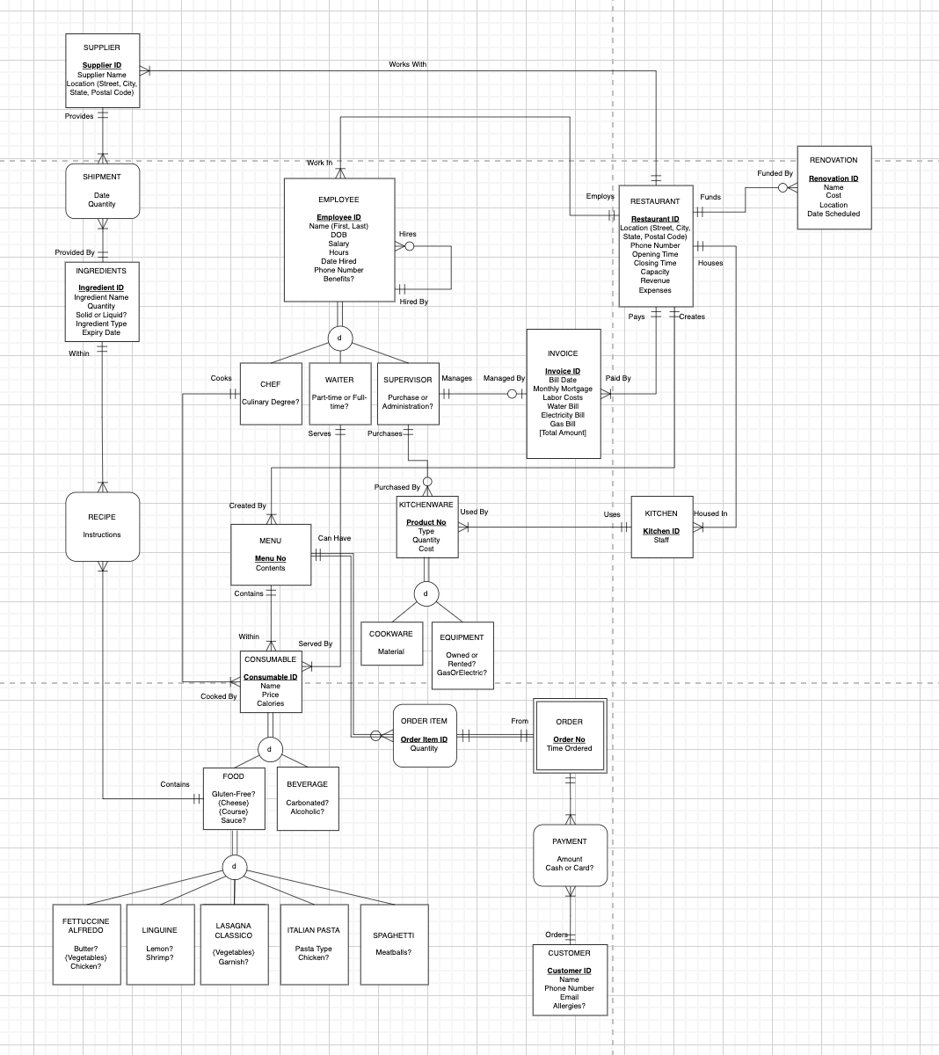

**Non-Normal Relations**

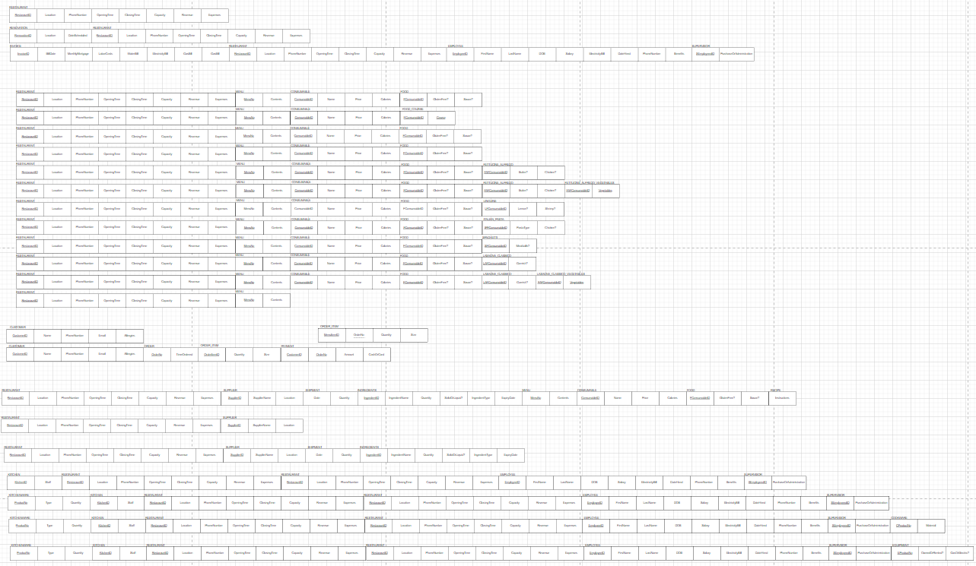

**Normal Relations**

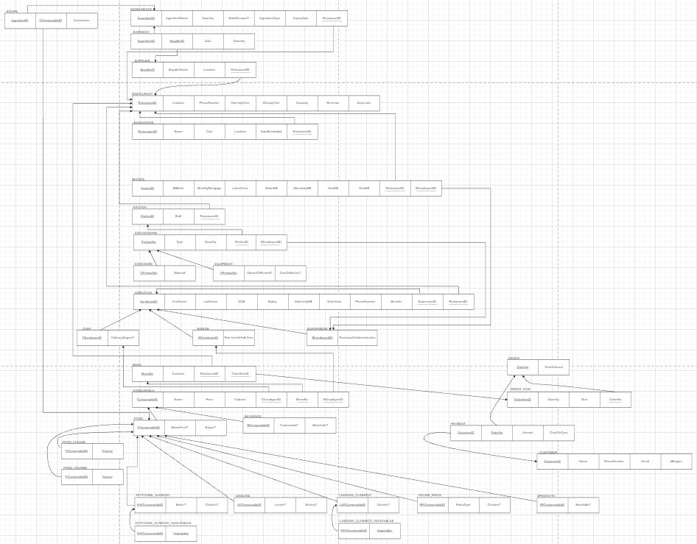

**Project Report**

Some people do not have technology assisting them in their businesses. This leads to unnecessary problems like unorganized, important documents and unsorted data. Having problems like these leads to countless hours wasted on allocating papers and rewriting data by hand. Time is money which in turn means that wasted time leads to losing money. This is why databases are needed to help resolve these issues. The database shown here is an example of a restaurant business database that organizes information given to it while storing it. Databases allow for any sort of inserted data to be retrieved in a matter of seconds compared to looking manually through stacks of papers for hours. Databases bring the benefits of automation which will help improve businesses in many different ways.

One of the benefits is increased profit and automation, a business with a database allows for time to be spent wisely on other aspects of the business which means more money will be made. Databases allow for the quick and easy analysis of data, this allows for quicker decision making, increased efficiency, enhanced security, and improved customer service. A database allows for quicker decision making by business owners since they will be receiving real-time information that helps with deciding on changes to adapt to trends and feedback. This coincides with improved customer service due to data on individual consumers being tracked and stored too. Trend-tracking is a huge factor of business, and that information can’t be kept on just paper. Observing information being inputted live creates opportunities for decisions to be made quicker. All this information is important, so it must be secured, which a database also does if the right measures are put in place.

All in all, a business with a database is superior to one without one. Databases are meant to make a company better since they provide so many benefits and come with almost no negatives. Technology advances in order to help improve society. Businesses adapting to the times with databases is a step closer to automation thus leading to more money.

LE Linguine, the restaurant business statement presented in this paper, is one that shows the changing process of a business idea with the help of databases. The initial idea of the restaurant was created from just solely thinking about the aspects of an everyday restaurant. As more progress was made with each step of creating a database, ideas adapted and changed to conform to modern businesses.

Starting off with the idea of using a database will greatly benefit any business, existing or start-up. Using a database not only allows information storage and access to an instant, but it also allows for the expansion of ideas for the business owner. An idea almost never stays the same throughout the process of making it a reality because that idea needs to be adapted. Le Linguine had to be changed multiple times as it was being transformed into a database. More information needed to be accounted for and some things needed to be removed since they were unnecessary.

This business concept developed more and more as the process changed our initial idea more and more into a database. La Linguine was thought to be a simple and affordable Italian food chain, but everything changed as the complex factors kept adding up. The ERD, EERD, normal relations, and the database implementation changed everything.

Going into detail, Le Linguine had so many planned aspects like renovations, online reservations, and planned locations. These were laid out ideas but were never expanded upon until more detail had to be added. The ERD and EERD helped set up the connections between all of the ideas while allowing for the attributes of each entity to be fully realized. The normal relations helped refine everything so that it could be implemented into a database. The physical sight of connected entities allowed for the ease of creating tables and inserting data into them using SQL.

Many aspects of the business statement had changed but they were for the better since the plan being database oriented helped it improve in terms of efficiency and effectiveness. Data was clear and concise by the end and relations between entities were set in stone which allowed for no errors.

This database-oriented business idea is a great example of how a database can make such a difference. Automation and profit were the goals that allowed for data to be collected and analyzed cleanly. Not a single sheet of paper was involved, which saved both time and money. Conceptually, the business statement presented an idea that was constantly improved upon. Databases exist with the goal of improving business and Le Linguine is a great example of this.

The ERD, EERD, and normal relations played a crucial role in establishing the relationships between entities in Le Linguine's database-oriented business model. The relationships between suppliers and restaurants, employees and restaurants, and consumables and menus were particularly important and were established using different types of relationships.

One-to-many relationships were used to model the relationships between suppliers and restaurants, where a supplier works with one restaurant, but a restaurant must work with one or more suppliers. Similarly, an employee works for one restaurant, but a restaurant can have one or more employees. In both cases, the decision to use a one-to-many relationship was because one entity has a unique relationship with multiple entities of another type.

On the other hand, many-to-many relationships were used to model the relationships between ingredients and suppliers, where an ingredient must be provided by many suppliers, and a supplier provides at least one ingredient. The decision to use a many-to-many relationship in this case was because each entity can be associated with multiple entities of another type, and vice versa.

The relationship between kitchenware and supervisors, where a supervisor may purchase one or more kitchenware, but kitchenware must be purchased by a single supervisor, was established using a one-to-many relationship. This decision was made de each kitchenware can be associated with only one supervisor, but a supervisor can purchase multiple kitchenware items.

The relationships between consumables, menus, and orders were modeled using one-to-many relationships. A menu must have many consumable items, and a consumable item is part of a menu. Similarly, an order must have at least one order item, and an order item belongs to an order. The decision to use one-to-many relationships in these cases was because one entity can be associated with multiple entities of another type.

Finally, the relationship between payment and order, where an order must have at least one payment, and a payment must have an order, was established using a one-to-one relationship. This decision was made because each order should have only one payment, and each payment should be associated with only one order.

In conclusion, the decision to use one-to-many, many-to-many, and one-to-one relationships in Le Linguine's database-oriented business model was based on the nature of the relationships between entities. By carefully modeling these relationships, the ERD, EERD, and normal relations allowed for efficient data storage and access, contributing to the success of the restaurant's business.

A logical data model is a representation of the data in an organization without reference to any database management system (DBMS) or physical storage considerations. It defines the structure of data, relationships between data elements, and the business rules that govern the data. Pertaining to Le Linguine’s, its entities are listed as follows: Consumables, Customer, Employee, Kitchen, Kitchenware, Ingredients, Invoice, Menu, Renovation, Restaurant, Supplier.

Each entity has particular attributes that allow them to work as a part of and enable the function of our DBMS. For instance, Restaurant entity, one of our most important, represents the Le Linguine’s open restaurant locations. It contains attributes such as a Restaurant ID, Location, Phone Number, Opening Time, Capacity, Revenue, etc. Another fundamental characteristic of our DBMS is that our entities are in third normal form (3NF), meaning they are free from multivalued attributes, partial dependencies, and transitive dependencies. From start to end, this process of removing anomalies makes our design become increasingly clear and readable. The final structure of some entities and their complete dependencies are shown below, in Figure 1.

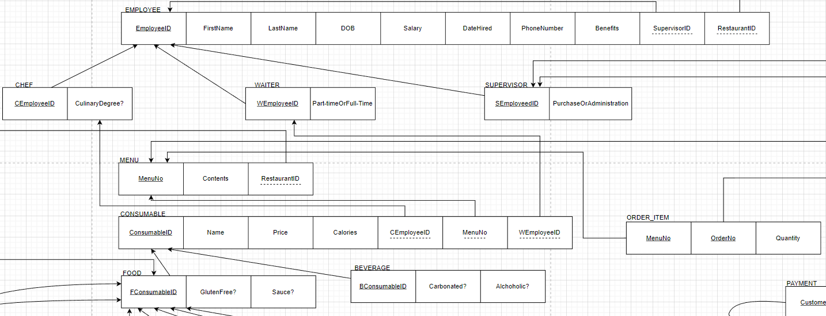

(Fig. 1)

While they did not begin as such, by refining our initial logical design, it became more powerful and efficient. Our DBMS also follows the business rule: all entity types (independent, dependent, associative) and each instance of those entities must utilize a unique identification key. All in all, a logical data model is a useful tool for organizing and understanding the data within an organization. The model discussed above represents the data of each Le Linguine establishment and provides a clear understanding of the relationships between the different entities. By following the business rules defined in the model, the organization can ensure the integrity and consistency of its data, which can ultimately lead to better decision-making and improved business processes.

Using sample information from select locations and the samples being of small size, it is possible to see the data behind what the customer’s order and anything else.

The first and most obvious analysis is the types of food and beverages ordered. As seen in the diagram "Food and Drink Popularity”, the ratio of non-veg food to veg is equivalent to non-alchoholic beverages to alcoholic.

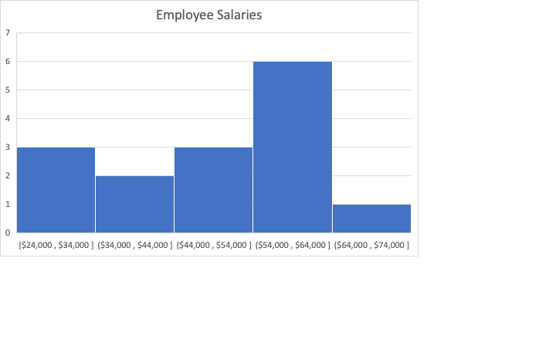

The second diagram, “Employee Salaries” shows the distribution of the employees’ salaries over intervals of $10,000 and across a range of $24,000 to $74,000.

To go further in depth with the data between the meals and drinks, it is possible to see how although the drinks may be ordered in the same quantity as the meals, the meals generate more profits for the business. Whether the drinks could generate more profits is a different ordeal, it is interesting to see the differences, and to develop business ideas from them. (“Meals vs. Drinks”)

Looking at the two diagrams, “Monthly Expenses and Revenues Per Location” above addressing the monthly revenue and the expenses, it is possible to further understand each location’s profits and compare it one another either directly or comparing how the differences in their expenses and revenues are, individually. These analyses allow the business to understand the differences in locations and develop plans to either change them or maintain them.

Implementing our database would have a significant impact on the business operations and profitability. Our database streamlines various aspects of their restaurant operations, from inventory management to customer service, to menu optimization, and financial performance tracking. The benefits of implementing a database are numerous, and this report will explore, below, how a database can enhance business operations and increase profits.

One of the greatest advantages our database provides is improved inventory management. With our database, restaurant owners can easily track the usage of ingredients and supplies. This allows for optimized purchasing decisions and helps reduce waste. By knowing exactly what ingredients are being used and in what quantities, restaurants can minimize spoilage and reduce overall costs. In the future, we would also implement the ability for equipment to alert restaurant owners when stock levels are low, allowing for timely restocking and ensuring that ingredients are always available when needed.

Customer data collection is another area where the database can be incredibly useful. By collecting customer information, restaurants can better understand their customer demographics and preferences. This information can then be used to create targeted marketing campaigns that are more likely to resonate with customers, driving repeated business and increased customer loyalty. These campaigns can also attract new customers who are more likely to enjoy the restaurant's offerings. This data collection can also help a restaurant optimize its menus. By tracking dish and beverage popularity, restaurants can make data-driven decisions about which dishes to offer, remove, or adjust pricing for, all of which can lead to increased profits. Additionally, the database can help restaurants identify trends in customer preferences, which can be used to create new menu items that are likely to be enjoyed.

Finally, the database can provide valuable data on financial performance. By keeping track of sales and expenses, restaurant owners can identify trends, track expenses, and make informed decisions about pricing and budgeting. This data can be used to identify areas for improvement and to make strategic decisions about the direction of the business.

To conclude, our database can have a significant impact on the operations and profitability of a restaurant. It aids customer order speed and accuracy and provides valuable data on financial performance. Those abilities, paired with the above-mentioned features and insights, help businesses make data-driven decisions and improve overall performance. By implementing the database, restaurants can operate more efficiently, attract new customers, increase customer satisfaction, and ultimately increase profitability.